2024
Quantifying the impacts of Single-Bed hospital accommodation: a case study
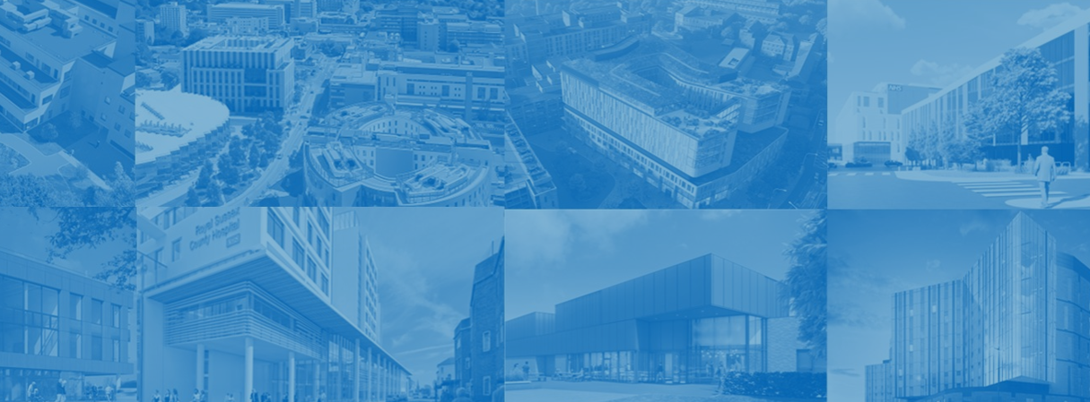

New Hospital Programme | TRANSFORMATION DIRECTORATE
Suitable for DIGITAL Distribution
Not for wider Sharing
Quantifying the impacts of Single-Bed hospital accommodation
A case study to support digital innovation

This case study has been generated specifically as pre-read information and for discussion at the SBR digital innovation Hackathon event on 1st October 2024. It is an abridged version of the analysis which is currently going through a formal publication process and will be shared in due course.
Background, purpose and aims:
Whilst there is a range of evidence that identifies potential impacts on patients, staff and hospital productivity of single-bed rooms (SBR), there are limited quantitative studies using examples from England.
Literature reviews have found mixed evidence on the impacts of single room hospitals, although one did conclude single room hospitals appear to have more advantages than disadvantages Bertuzzi et al., 2023; Taylor et al., 2018; van de Glind et al., 2007; Voigt et al., 2018). A recent systematic review suggested any clinical or economic benefits are likely to be small in routine care, but that benefits would be more likely to be seen in intensive care (Bertuzzi et al., 2023).
This study of the impacts of switching hospital inpatient beds from multi to SBR accommodation, therefore, aims to add additional insight to the underpinning assumptions of the NHP programme around SBR using both published and routine hospital data.
The aim was to evaluate the direction and scale of impacts on a range of metrics after hospitals switched to SBR. In order to do so we identified 7 hospital sites acting as ‘natural experiments’ across England between 2010 and 2022.
Methods:
We screened a large range of published aggregated data from multiple sources to identify relevant and suitable metrics where there were both adequate and consistent time series data to measure before and after the switch of hospitals to SBR. This included, where existing measures were not published, analysis of Secondary Uses Service (SUS) hospital inpatient routine data at site-level.

Figure 1. Final set of impact measures evaluated in the study
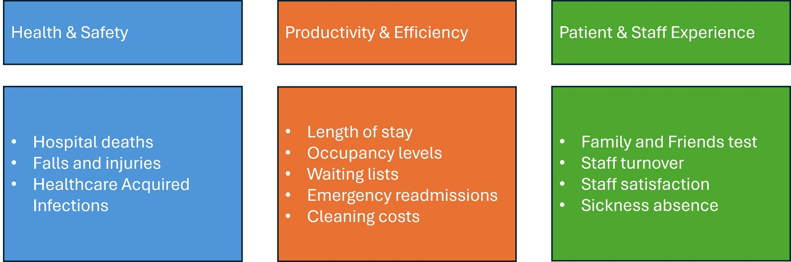
We used Causal Impact Analysis (CIA, Broderson et al., 2015) to quantify the post-SBR changes compared to a pre-SBR projection for each measure and each hospital. The counterfactual was modelled using data for the site of interest as well as up to 5 similar hospital sites (controls) across matched time periods.
The controls were selected based on the size, structure and case-mix of all other hospitals across England at the time of each switch to SBR.
Figure 2. Example of causal impact analysis on mean length of stay at hospital x.
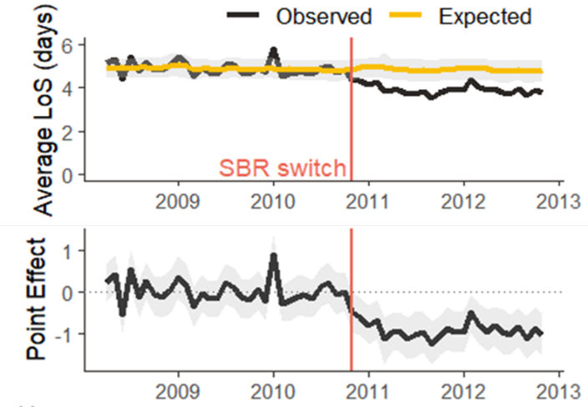
Key results:
The impact of switching to single occupancy rooms in hospital is highly variable both within indicator measures and between hospitals. We find no clear evidence to support a significant increase in productivity or efficiency in single-room hospitals though results tend towards the positive. We also find no clear evidence to indicate a negative impact on patient safety (which could be seen as a favourable finding) or to support a reduction in hospital-acquired infections. Our results do suggest that single occupancy rooms may significantly impact staff wellbeing and productivity.
Figure 3. Direction of impacts across hospitals and metrics
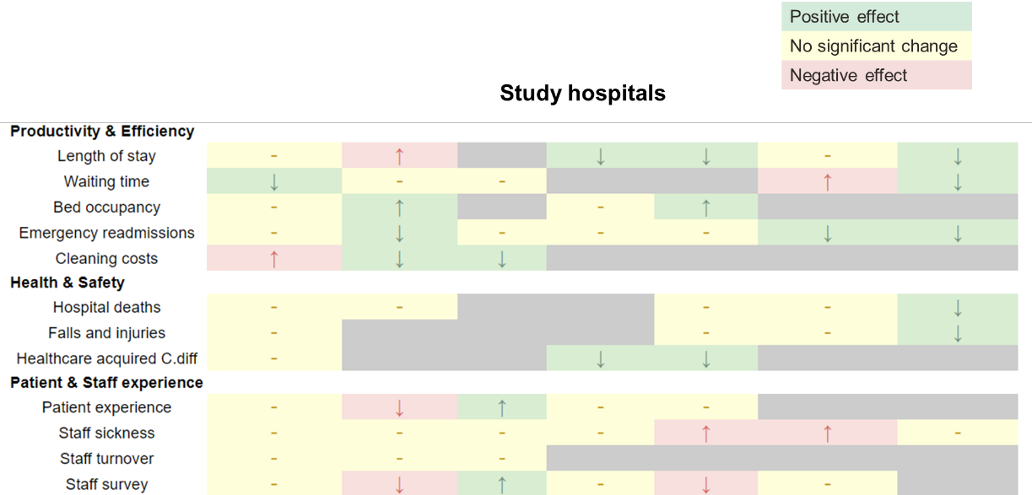

Figure 4. Meta-analyses of the impacts at general acute hospitals (specialist providers were excluded as their results may not be generalisable to future general acute hospitals)
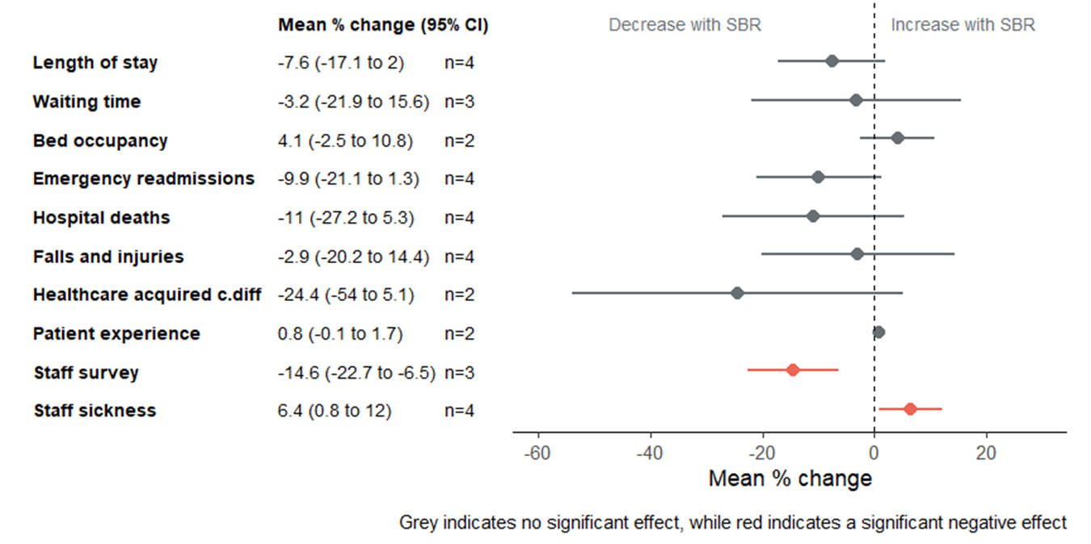
Limitations:
Our analyses rely on historical data collections meaning that some data recording does not go back as far enough to use for all the study hospitals or there are gaps/anomalies in the time series. Additionally some data were affected by the timing of the COVID-19 pandemic. This means that for some measures we have limited data which may impact the reliability of our findings.
The number of sites in the control pool were also very limited for two of the specialist centres, which may have impacted the quality of the model fit and reliability of the outcomes. Furthermore, our meta-analyses are limited due having only 4 general acute hospital study sites.
Some variables are only available at provider level, so where providers have more than one site any change that may occur following a switch to single bedrooms at one site will be diluted by a lack of change at the providers' other sites. Some measures are recorded quarterly (bed occupancy) or annually (cleaning costs and staff survey), so we have less data points with which to fit our models and assess outcomes.
To assess some of the impacts of interest we have needed to use a proxy measure, e.g. staff sickness and staff turnover as a proxy for staff experience and median waiting time as a proxy for hospital productivity.
When the sites switched to single bedrooms there are likely to have been other changes to how services operate and at multi-site providers there may also have been changes to what services are provided at which sites, hence there are likely to be confounding factors that influence our results.
Discussion:
Whilst the results are mixed (and need to be contextualised by local circumstances, policies, cultures and environments) there is a clear need to more reliably measure and monitor these and other outcomes before, during and after the implementation of SBR builds under the NHP and beyond.
Mitigating against these impacts will require systems and actionable data - data that is not necessarily currently captured. As such, this will also likely require digital enablement and/or investment in new technologies.
Some examples could be:
- quick-response patient and staff well-being surveys collected through touchpads or tablets
- remote monitoring and warning systems for early-sign of infections or fall events
- staff and equipment movement tracking to support flow and ward/room/stores placements

References:
Bertuzzi A, Martin A, Clarke N et al. Clinical, humanistic and economic outcomes, including experiencing of patient safety events, associated with admitting patients to single rooms compared with shared accommodation for acute hospital admissions: a systematic review and narrative synthesis. BMJ Open. 2023 May 5;13(5):e068932. doi: 10.1136/bmjopen-2022-068932.
Brodersen KH, Gallusser F, Koehler J et al. Inferring causal impact using Bayesian structural time-series models. The Annals of Applied Statistics. 2015 9(1), 247-274
Taylor E, Card AJ, Piatkowski M. Single-Occupancy Patient Rooms: A Systematic Review of the Literature Since 2006. HERD. 2018 Jan;11(1):85-100. doi: 10.1177/1937586718755110.
van de Glind I, de Roode S, Goossensen A. Do patients in hospitals benefit from single rooms? A literature review. Health Policy. 2007 Dec;84(2-3):153-61. doi: 10.1016/j.healthpol.2007.06.002.
Voigt J, Mosier M, Darouiche R. Private Rooms in Low Acuity Settings: A Systematic Review of the Literature. HERD. 2018 Jan;11(1):57-74. doi: 10.1177/1937586717702597.

